LAB ASSIGNMENT – 2
Exploring Additional AI Coding Tools beyond Copilot
Gemini (Google Colab) and Cursor AI

Name | Ch. Anirudh Bharadwaj
Roll No. | 2503A52411
Branch / Section | Batch 14

Objective: To explore AI-assisted coding using Google Gemini, GitHub Copilot and Cursor AI, and compare their code generation, explanation, refactoring and usability.
1. Lab Objectives
- Explore and evaluate Google Gemini for AI-assisted coding within Google Colab.
- Understand and use Cursor AI for code generation, explanation and refactoring.
- Compare outputs and usability between Gemini, GitHub Copilot and Cursor AI.
- Perform code optimization and documentation using AI tools.
2. Lab Outcomes
- Generate Python code using Google Gemini in Google Colab.
- Analyze the effectiveness of code explanations and suggestions by Gemini.
- Set up and use Cursor AI for AI-powered coding assistance.
- Evaluate and refactor code using Cursor AI features.
- Compare AI tool behavior and code quality across different platforms.
3. Task 1 – Statistical Summary for Survey Data
Scenario: A data analyst intern is working with survey responses stored as numerical lists.
Prompt used with Gemini:
Write a Python function that accepts a list of numbers and calculates
the mean, minimum, and maximum values. Return the results clearly
and include a sample input and output.

Generated / final Python code:
def statistical_summary(numbers):
if not numbers:
return None
mean = sum(numbers) / len(numbers)
minimum = min(numbers)
maximum = max(numbers)
return mean, minimum, maximum
survey_data = [10, 20, 30, 40, 50]
mean, minimum, maximum = statistical_summary(survey_data)
print("Mean:", mean)
print("Minimum:", minimum)
print("Maximum:", maximum)

Sample Output:
Mean: 30.0
Minimum: 10
Maximum: 50

Code explanation: The function receives a list of numbers, calculates the mean using the sum divided by the number of elements, and uses the built-in min() and max() functions to find the minimum and maximum values. The function also handles an empty list.
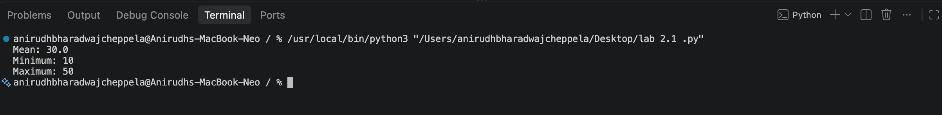

4. Task 2 – Armstrong Number: AI Comparison
Scenario: AI tools are being evaluated for numeric validation logic.
4.1 Gemini Prompt
Generate a clear and beginner-friendly Python program to check
whether a given number is an Armstrong number. Explain the logic
step by step and include a sample output.

4.2 GitHub Copilot Prompt / Instruction
Create a Python function that checks whether an integer is an
Armstrong number. Keep the code concise, readable and reusable,
and show an example of calling the function.

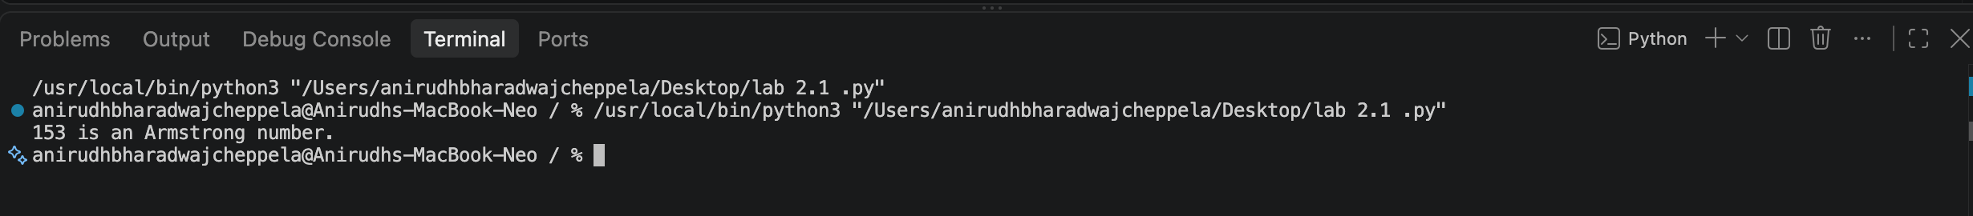

4.3 Armstrong Number Code
def is_armstrong(number):
digits = str(number)
power = len(digits)
total = sum(int(digit) ** power for digit in digits)
return total == number
n = 153
if is_armstrong(n):
print(n, "is an Armstrong number.")
else:
print(n, "is not an Armstrong number.")

Sample Output: 153 is an Armstrong number.
4.4 Comparison
Aspect | Gemini | GitHub Copilot
Code style | Generally explanatory and beginner-friendly. | Generally concise and focused on implementation.
Logic clarity | Provides clear explanation of the Armstrong-number logic. | Produces direct logic suitable for use in a program.
Readability | Easy to follow with supporting explanation. | Readable and compact.
Main strength | Useful for learning and understanding the logic. | Useful for fast code completion and implementation.
Observation: Both tools can generate a correct Armstrong-number checker, but their presentation may differ. Gemini is useful when detailed explanation is required, while Copilot is useful for quick code generation inside the development environment.
5. Task 3 – Leap Year Validation Using Cursor AI
Scenario: A calendar module needs to validate whether a given year is a leap year.
5.1 Prompt 1 – Basic Version
Write a simple Python program that asks the user for a year
and checks whether it is a leap year. Keep the program beginner-friendly.

Version 1:
year = int(input("Enter a year: "))
if year % 400 == 0:
print(year, "is a leap year.")
elif year % 100 == 0:
print(year, "is not a leap year.")
elif year % 4 == 0:
print(year, "is a leap year.")
else:
print(year, "is not a leap year.")

6. Task 4 – Student Logic + AI Refactoring (Odd/Even Sum)
Scenario: The developer must write the initial logic before using AI for refactoring.
6.1 Original Student Code
numbers = (1, 2, 3, 4, 5, 6, 7, 8, 9, 10)
odd_sum = 0
even_sum = 0
for number in numbers:
if number % 2 == 0:
even_sum += number
else:
odd_sum += number
print("Sum of odd numbers:", odd_sum)
print("Sum of even numbers:", even_sum)

Original Output:
Sum of odd numbers: 25
Sum of even numbers: 30

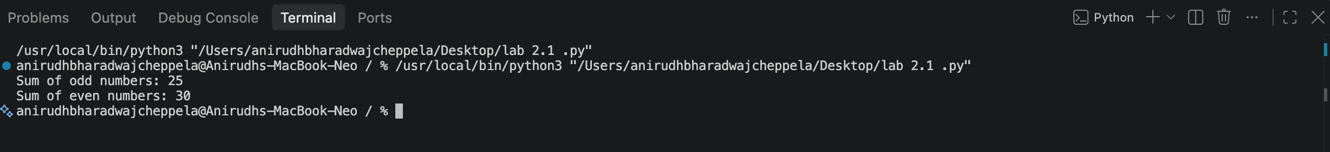

6.2 AI Refactoring Prompt
Refactor the following Python program for better readability and
reuse without changing its output. Keep the solution simple and
explain the improvements made.

6.3 Refactored Code
def sum_odd_even(numbers):
odd_sum = sum(n for n in numbers if n % 2 != 0)
even_sum = sum(n for n in numbers if n % 2 == 0)
return odd_sum, even_sum
numbers = (1, 2, 3, 4, 5, 6, 7, 8, 9, 10)
odd_sum, even_sum = sum_odd_even(numbers)
print("Sum of odd numbers:", odd_sum)
print("Sum of even numbers:", even_sum)

Refactored Output:
Sum of odd numbers: 25
Sum of even numbers: 30

6.4 Explanation of Improvements
- The calculation is placed inside a reusable function.
- Python's sum() and generator expressions make the calculation concise.
- The original output and logic are preserved.
- The code is easier to reuse with different tuples of numbers.
- The structure separates the calculation from the input data and output.
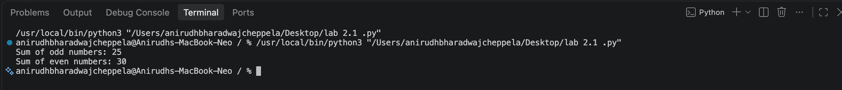

7. Conclusion
This lab demonstrated how AI coding tools can assist with Python programming tasks. Gemini was explored for code generation in Google Colab, GitHub Copilot was used for comparison in numeric logic generation, and Cursor AI was used for generating multiple versions of a leap-year program and for AI-assisted refactoring. The exercises show that AI tools can improve development speed, readability and documentation, while the developer should still understand and verify the generated code.
8. Submission Checklist
- Prompts used for Gemini, GitHub Copilot and Cursor AI are included.
- Python code and sample outputs are included for all four tasks.
- Task 2 contains an AI comparison table.
- Task 3 contains two Cursor AI prompt/code versions and a comparison.
- Task 4 contains original code, refactored code and improvement explanation.
- Replace each screenshot placeholder with the corresponding screenshot before submission.

